The Control App
New Users
Step 1 : Register
thecontrolapp.co.uk/Pages/Register.aspx
Enter screen name – This is the user name used throughout the app. (Must be unique)
Enter email – currently not used for validation but it will in the future.
Enter Password – User throughout the app to make sure you are you.
Enter Role – Leave this as sub for now
Random opt in – with this set to opt in you may receive random command from strangers.
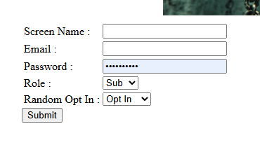
If your registration is successful the website will take you back to the front screen.
Step 2 : Log in
thecontrolapp.co.uk/Pages/Login.aspx
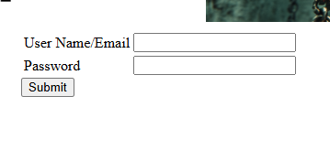
Enter either your user or email address and password then click submit.
If you log in successfully you will be taken to the sub main page.
One here there are 2 important pages to look at :
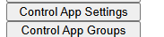
Control app setting :
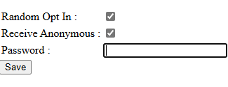
This page allows you to change you password and random opt in choice. It also allows you to to choose if you wish to receive commands from anonymous users.
Control App groups :
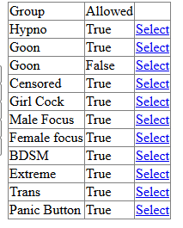
On this page you can opt into and out of groups depending on your preference.
Step 3 : Get the app
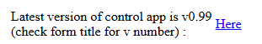
On the main page you will see this section and by clicking the “Here” button it will download the latest app.
Unzip the downloaded file and double click either installer.
Once complete you will see an icon on your desktop :
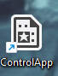
Double click this icon.
In the system tray :
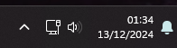
Click the up arrow and you will see some icon :
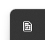
Right click this icon :
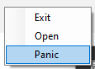
There are 3 option here:
Exit : closes the app and any open popups.
Open : Opens the main application.
Panic : This closes all open forms in a panic.

Step 4 : Initialise the app
Click the open option.
As soon as It opens click the setting at the top :
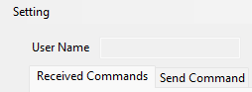
Within this you will see 2 setting :
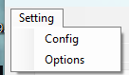
Click the config option
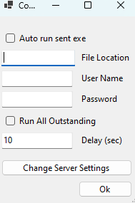
Auto run sent exe – This option is risky as it will run any exe files sent to you.
File location – this will automatically set itself to your download location however you may wish to point it at a different folder.
User name – enter your user name here
Password – enter your password here
Run All Outstanding – this will all commands that are waiting when you open the application also a little risky.
Delay – this is the delay between each outstanding command
Change server setting – this will take you to “Control app setting” page seen above.
Click ok then click the options :
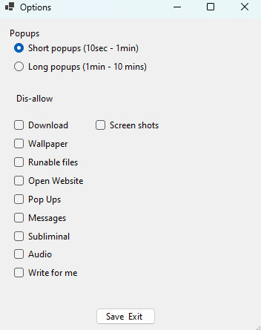
Popups – this allows you to select how long the popups are visible for.
The “dis-allow” area allows you to stop certain command option.
One complete press save exit button.
Once complete you will return to the main screen :
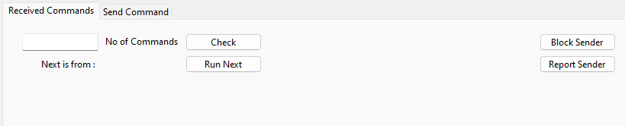
The text box next to “No of Commands” will show how many commands are waiting to be run.
“Next is from :” will show you if the next command is from “user”, “anon” or “group”
“user” and “group” can be responded to on the send command tab.
“anon” can not be responded to, blocked or reported.
The “check” button will check to see how many outstanding commands you have.
The “Run Next” button will run the next command.
The “Block Sender" button will block the sender of the last message as long as the sender was a user.
The “Report Sender" button will block and report the sender of the last message as long as the sender was a user.

